1. Using the three separate words “Oracle,” “Internet,” and “Academy,” use one command to produce the following output:
The Best Class Oracle
Internet Academy

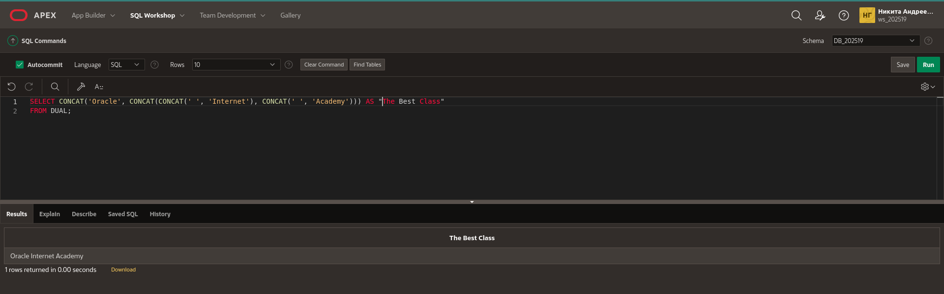
- Use the string “Oracle Internet Academy” to produce the following output:
The Net
net

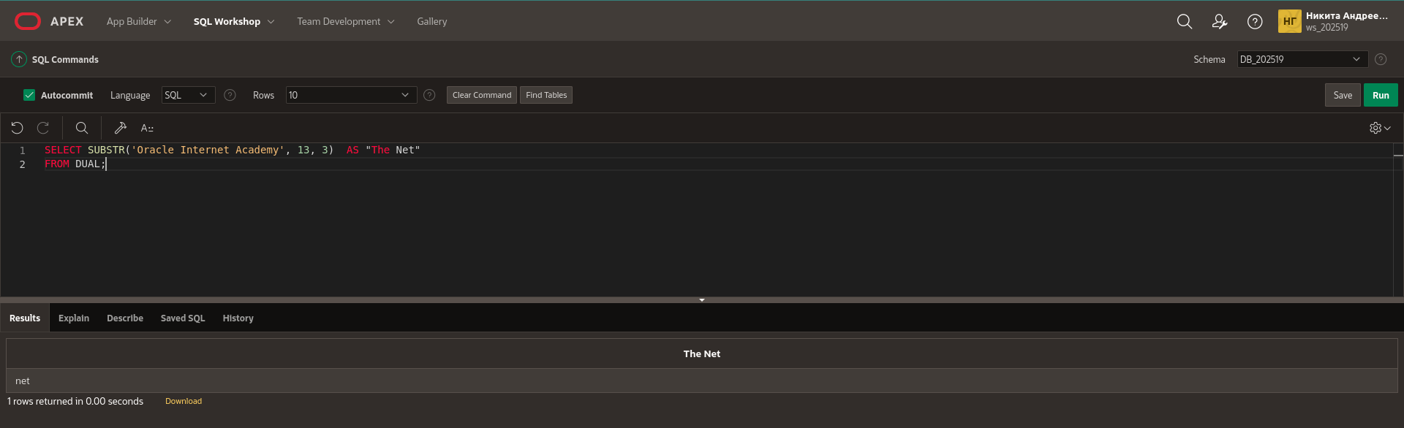

3. What is the length of the string “Oracle Internet Academy”?

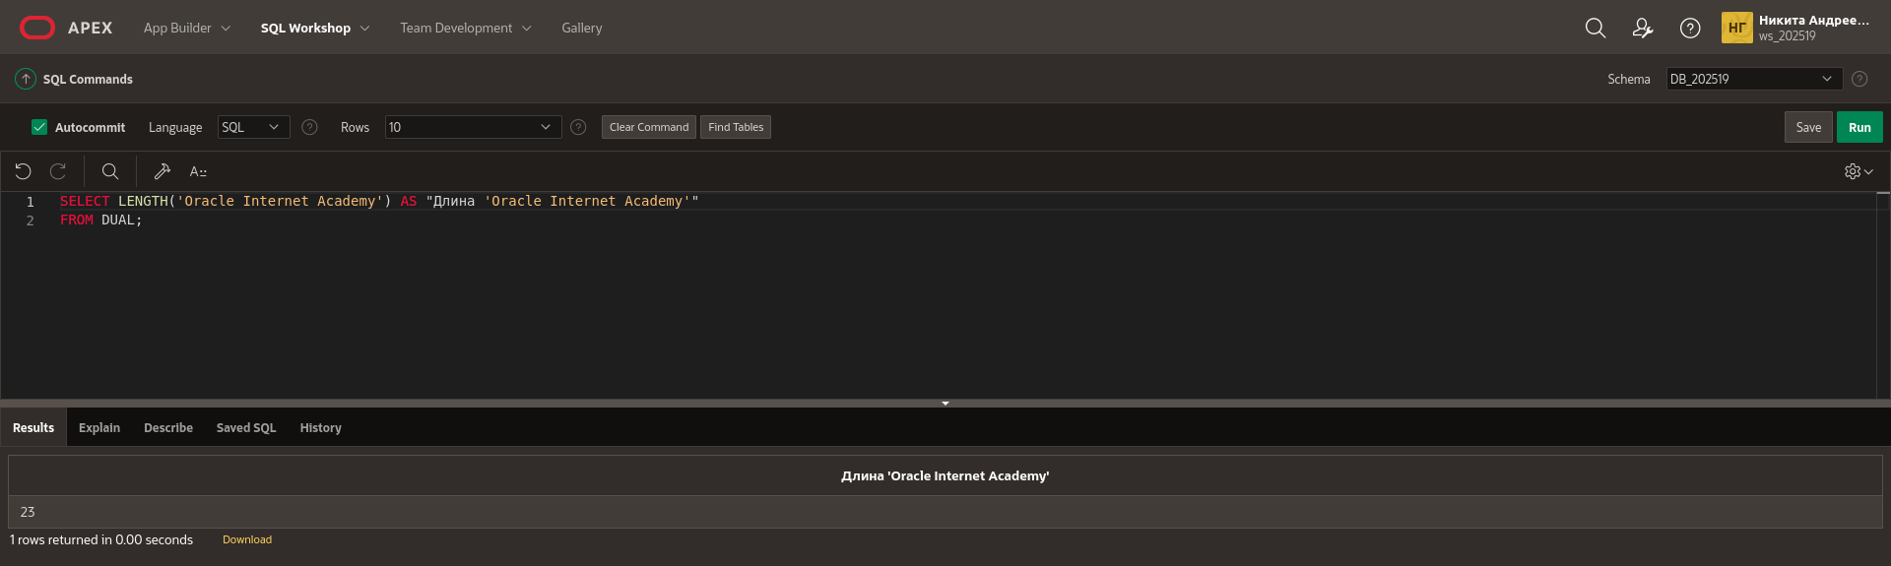
4. What’s the position of “I” in “Oracle Internet Academy”?
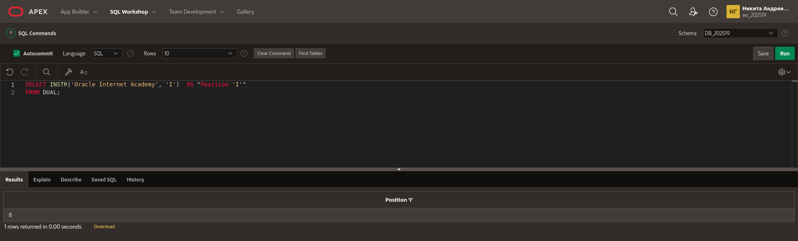

5. Starting with the string “Oracle Internet Academy”, pad the string to create ****Oracle****Internet****Academy****
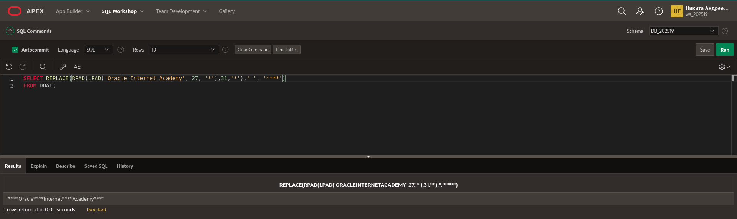
6. Starting with the string “Oracle Internet Academy”, pad the string to produce: Oracle$$$Internet$$$Academy
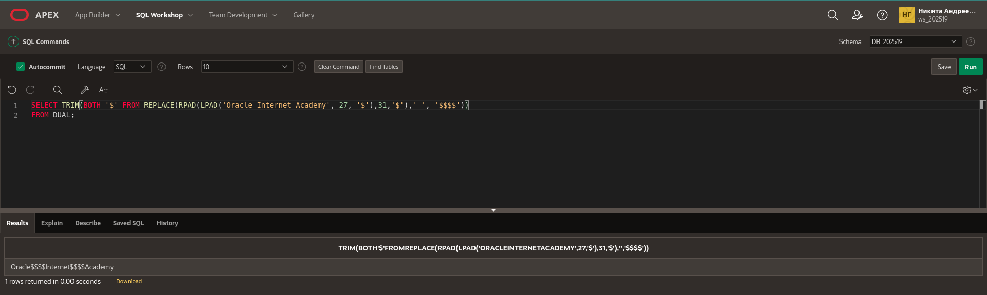

7. Using the string ‘Oracle Internet Academy’, produce the output shown using the REPLACE function.

The Best Class
Oracle 2013-2014 Academy
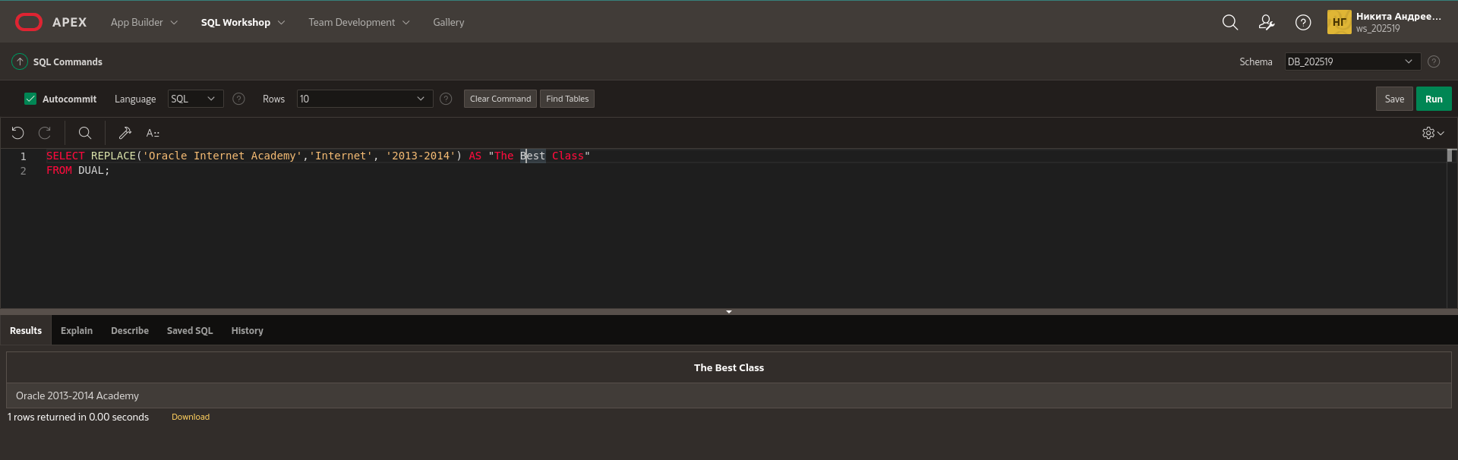

8. List the order date and the order total from the Global Fast Foods F_ORDERS table. Name the order total as TOTAL, and fill in the empty spaces to the left of the order total with $.

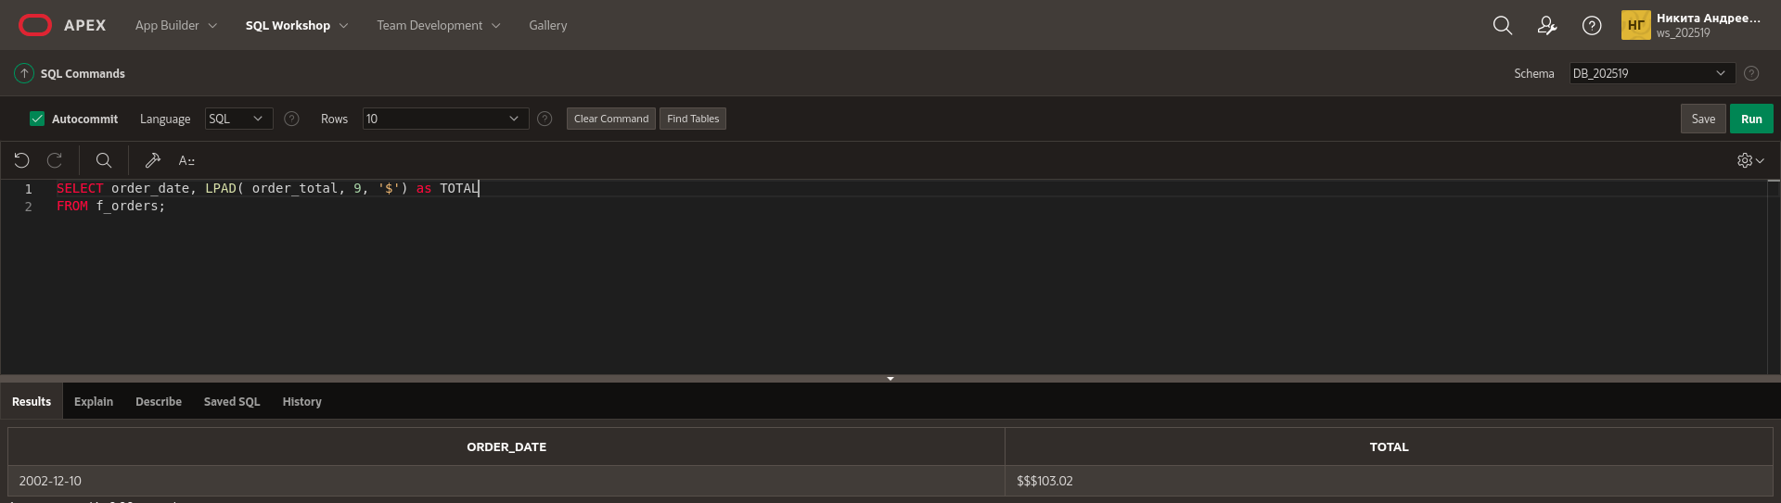
9. Write a query that will output a column called “ADDRESS” which has the following information: ZOE TWEE 1009 OLIVER AVENUE BOSTON, MA 12889. Use the Global Fast Foods F_CUSTOMERS table.
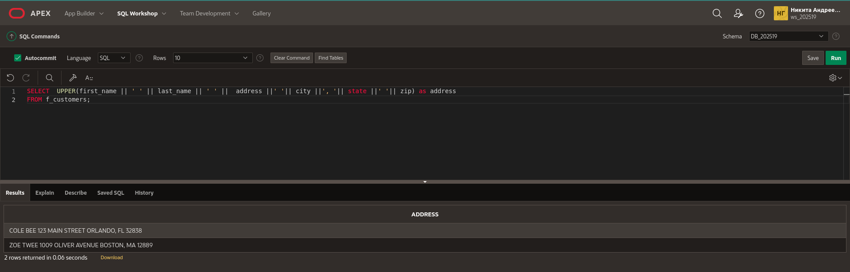
10.Write a query to return the first character of the first name concatenated to the last_name, the salary, and the department id for employees working in department 20. Give the first expression an alias of Name. Use the EMPLOYEES table. Change the query to use a substitution variable instead of the hard coded value 20 for department id. Run the query for department 30 and 50 without changing the original where-clause in your statement.
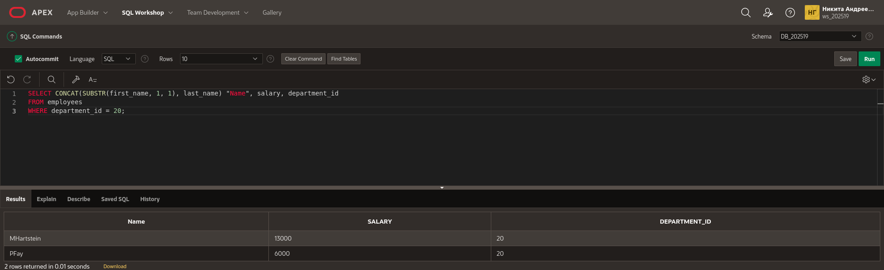
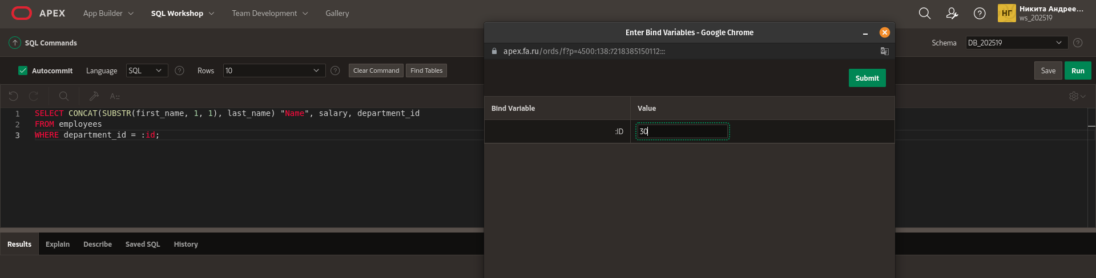
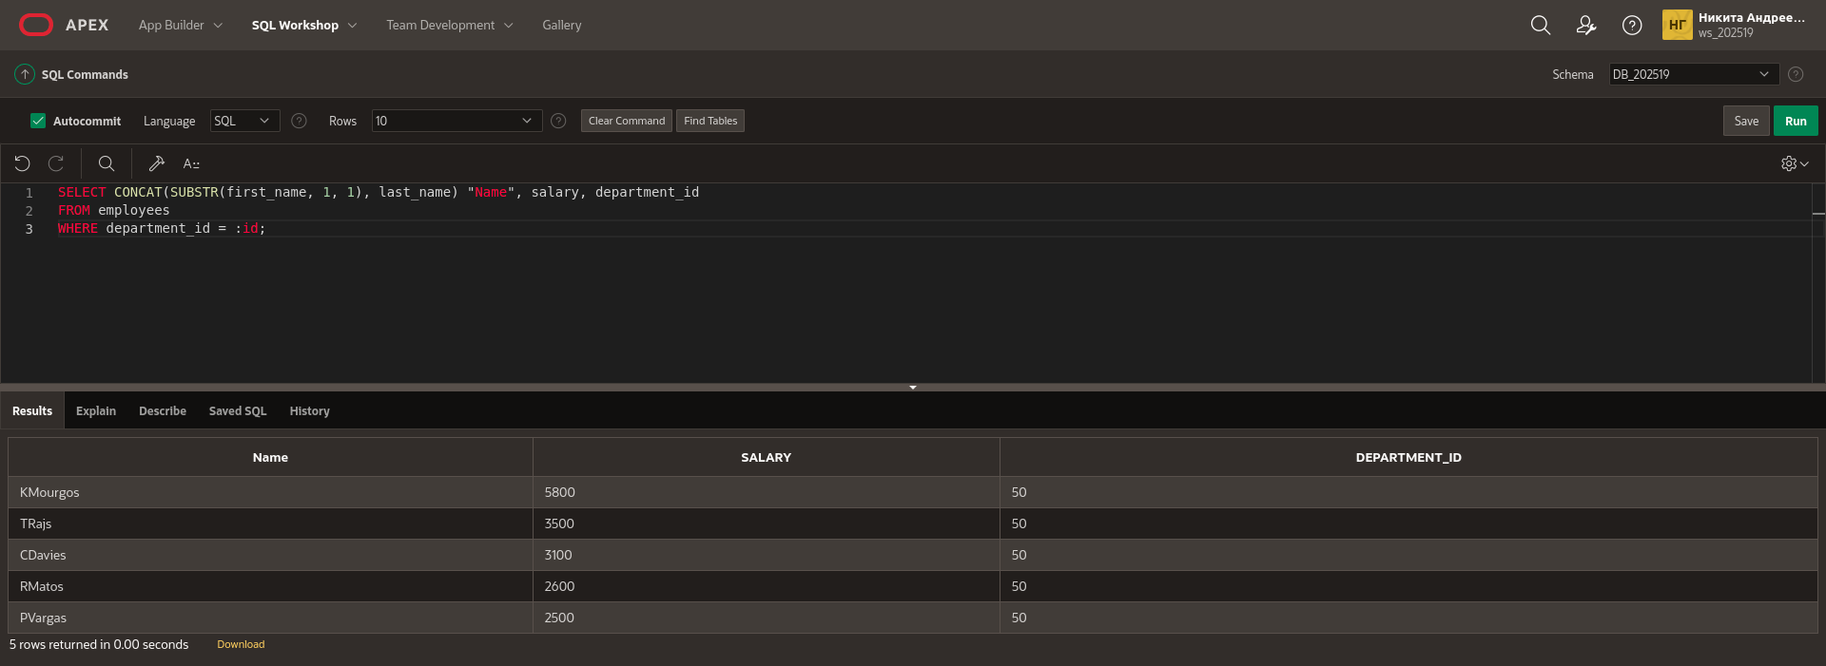

11.Using a substitution variable for the department name, write a query listing department id, department name, and location id for departments located in the_department_of_your_choice. Use the DEPARTMENTS table. Note: All substitution variables in OAE are treated as character strings, so no quotes (‘ ‘) are needed.
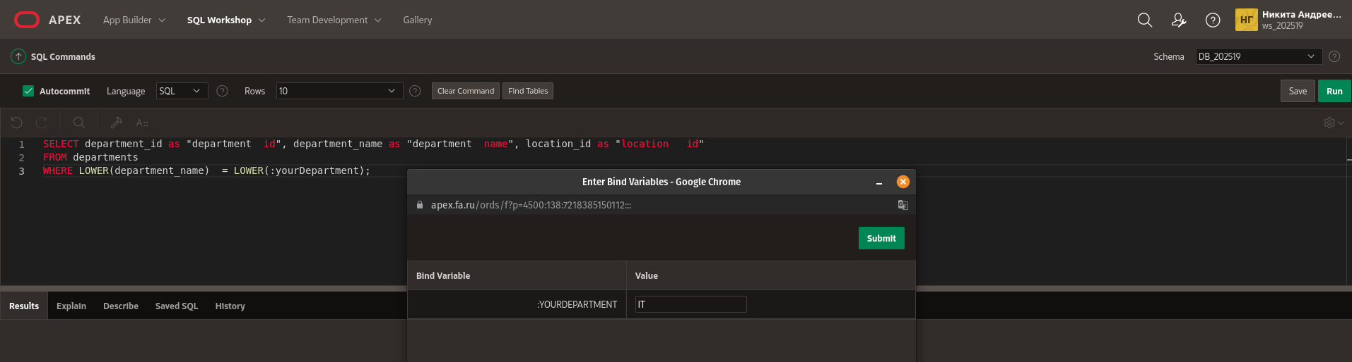
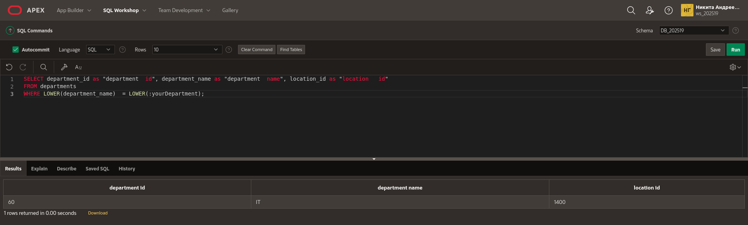
12.Write a query that returns all the employee data depending on the month of their hire date. Use the EMPLOYEES table. The statement should return the month part of the hiredate which is then compared to an abbreviated month (JAN, FEB, MAR) passed into the query via a substitution variable.

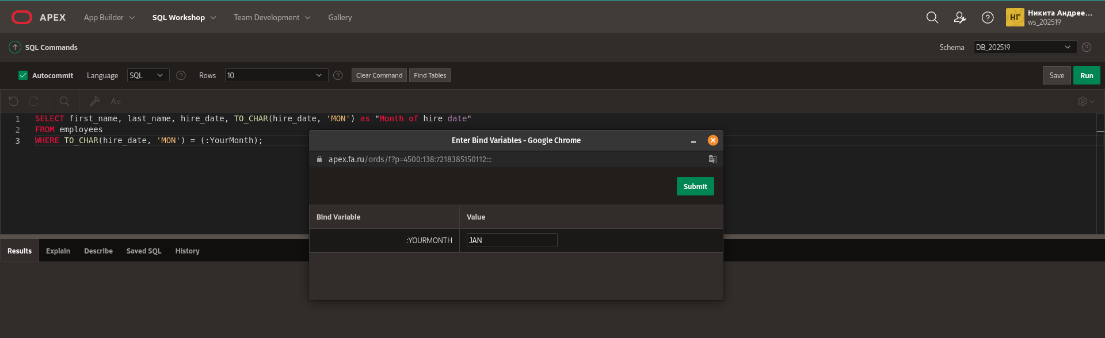
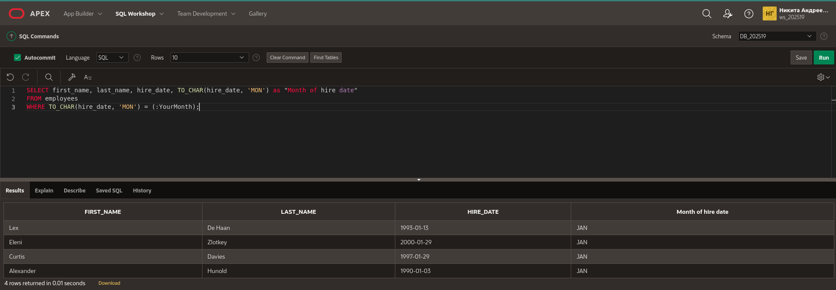

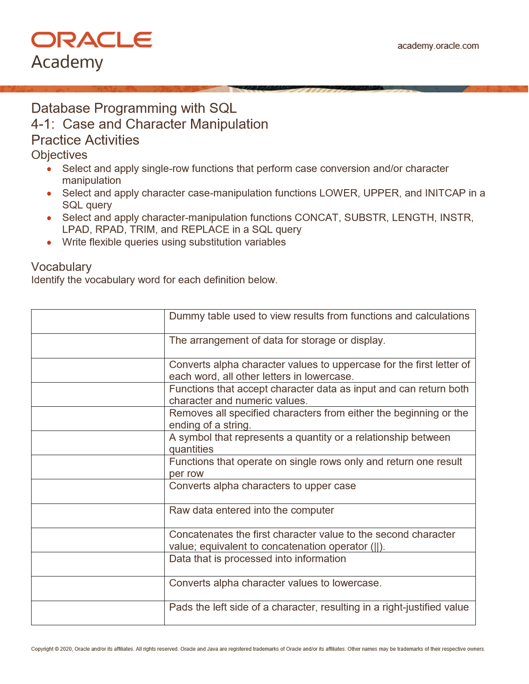
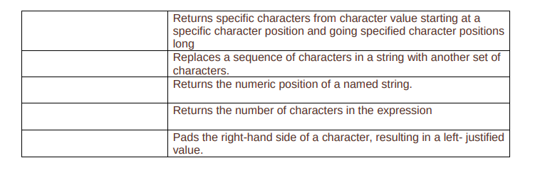

Dual
Format
InitCAP
Character functions
Trim
Expression
single row function
UPPER
input
CONCAT
Output
LOWER
LPAD
SUBSTR
REPLACE
INSTR
LENGTH
RPAD

